**Forgot Password Api: End Point /forgot-password**

Error is showing inside the message not in the errors.

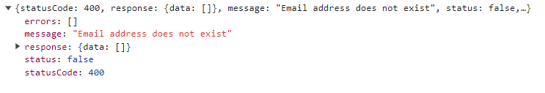

**CheckOtp Api: End Point /verify-otp**

If user is coming from the forgot password process so that time we’ll don’t have the token but verify-otp api required Bearer Token

**Login Api: End Point /login**

If I’m signup as an provider and login as an employer so it is successfully login not giving an error that your credentials is not valid or something else.

**Login Api: End Point /login**

If account is not verified still it is giving isActive: 1 in the user object.

**CheckOtp Api: End Point /verify-otp**

Error is showing inside the message not in the errors.

